AI-Based Smart Navigation System for Visually Impaired Users with a LiDAR, Raspberry Pi and Haptic Feedback

Abstract
Navigation of blind people is an important issue to be considered. They most commonly use white canes for obstacle detection, meanwhile memorizing all locations they are getting familiar with. In a new or unfamiliar environment they totally depend on individuals passing by to enquire for a certain area. In the world of sophisticated technology along with various sensors, there should be a system with the most basic innovation to make their life a bit easier. This innovation should complement the white canes: give alarm to the user about obstacles a few meters away and give direction for going to a particular area.
Introduction
This paper proposes that mechanical feedback coupled to sensor technology as well as perception and planning algorithms is a potential solution to enable people with visual impairments to navigate their environment discreetly and effortlessly. This solution is not an attempt to recreate sight, but to process sensor information into useful navigational information that the user can rely on to create a mental map of their surroundings. Embedding small and lightweight sensors along with haptic devices in clothes allows for seamless integration of wearable navigation technology into the lives of visually impaired people. A related study mounted a depth camera to glasses, which was used to build up an occupancy map; four distinct navigation cues were used as output, displayed on a tactile feedback vest. The system provided a speed advantage in steering a blind user through the map only when used in conjunction with a white cane; additionally, the system did not provide local obstacle detection.
Existing system
- White cane
- Blind stick with sensors
- Navigation system with audio feedback
Proposed system
The system proposed here consists of ALVU (Array of LIDAR and Vibrotactile Units) for navigation and feedback. This system can be designed around any embedded processor like raspberry pi. With efficient design of power supply this system can be made portable.

Block diagram
LiDAR
Obstacle Detection

Raspberry pi
Vision AI Processing
Object Detection & Control

Haptic strap
Vibration Motor

Visually Impaired User

Block diagram explanation
Here microcontroller is the central part and the LIDAR is connected to the microcontroller. We can use any type of microcontroller or SoC depending on application. The sensor that can measure the distance. It used for monitoring the obstacles detection. They output form the haptic strip. Shorter distances to obstacles are relayed by increased pulse rates with higher vibration strength. For example, when there is an obstacle to the right of the user, he or she feels strong frequent pulses on the right side through the haptic strap. For the user, this leads to the perception of an obstacle to the right. The user can then avoid the obstacle by stepping left. After stepping left, the pulses on the right side stop and the user perceives that there is no longer an obstacle on his or her right side.
Hardware required
- Lidar
- Raspberry pi
- Haptic strie
Software required
- Raspberry Pi OS
- Python 3
- OpenCV
- GPIO Libraries
Working Principle

- The LIDAR sensor continuously scans the surroundings.
- Distance data is sent to the Raspberry Pi.
- The Raspberry Pi processes the obstacle distance.
- If an obstacle is detected within a specific range, the haptic motor vibrates.
- Stronger vibration indicates closer obstacles.

Architecture diagram
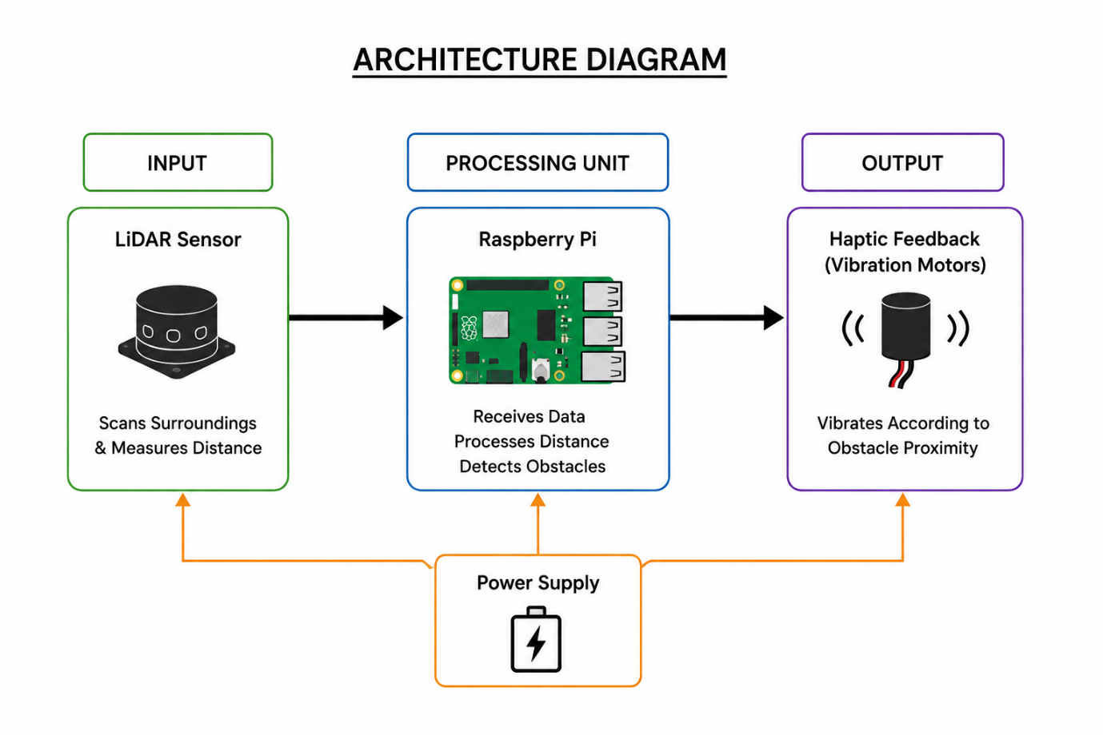
Technologies Used

- Raspberry Pi 4
- LiDAR Sensor
- Python 3
- OpenCV
- GPIO Interface
- Haptic Feedback System
- IoT Embedded System
Vision AI is implemented in the Raspberry Pi using OpenCV for intelligent obstacle detection and environmental understanding

Applications

- Smart assistive devices
- Indoor navigation
- Obstacle detection systems
- Wearable healthcare technology
- Smart mobility systems
Features

- Real-time obstacle detection
- Haptic vibration alerts
- Portable and lightweight design
- Low-cost implementation
- Easy to use

Advantages

- Improves mobility for visually impaired users
- Provides better obstacle awareness
- Low power consumption
- Cost-effective system
- Simple implementation

Future Enhancements

- Add voice assistance
- Integrate GPS tracking
- Add AI-based object recognition
- Mobile application support
- Wireless communication features

Conclusion

The proposed system successfully demonstrates an AI-based smart navigation system for visually impaired users using LiDAR and haptic feedback technology. The system detects nearby obstacles and provides real-time vibration alerts, helping users navigate safely and independently.

Reference
[1] WHO, “Visual impairment and blindness - fact sheet n282,” http://www. who.int/mediacentre/factsheets/fs282/en/, 1 Aug. 2014, accessed: 20166-23.
[2] ——, “World sight day - 13 october 2011,” http://applications.emro.who.
int/dsaf/EMROPUB 2011 EN 739.pdf, 13 Oct. 2011, accessed: 20167-6.
[3] S. Maidenbaum, S. Hanassy, S. Abboud, G. Buchs, D. R. Chebat, S. Levy-Tzedek, and A.
Amedi, “The ’EyeCane’, a new electronic travel aid for the blind: Technology, behavior &amp;
swift learning,” Restor. Neurol. Neurosci., vol. 32, no. 6, pp. 813–824, 2014.
[4] A. Cosgun, E. A. Sisbot, and H. I. Christensen, “Guidance for human navigation using a
vibro-tactile belt interface and robot-like motion planning,” in Robotics and Automation
(ICRA), 2014 IEEE International Conference on, 2014, pp. 6350–6355.
[5] V. Filipe, F. Fernandes, H. Fernandes, A. Sousa, H. Paredes, and J. Barroso, “Blind
navigation support system based on microsoft kinect,” Procedia Comput. Sci., vol. 14, pp.
94–101, 2012.
[6] Y. H. Lee and G. Medioni, “Wearable RGBD indoor navigation system for the blind,” in
Computer Vision-ECCV 2014 Workshops, vol. 8927, 2014, pp. 493–508.

